THANUSREE ENTERPRISES

Date | May 07, 2018

Praveen D,

No.24/19 2nd Street

Hyder Garden Jamalia Perambur

Chennai -600012

Contact Number - 9445198956

Dear Praveen D,

We are pleased to offer you the position of Project Associate, in band 05. Attached are the specific terms and conditions of our offer, please read these important details carefully.

Acceptance and Commencement

Your appointment will be effective on your joining date, i.e. 07 May, 2018. Please contact us immediately if you require an alternative joining date. If you do not confirm your acceptance or we are unable to set an alternative date, this offer will be withdrawn

To confirm your acceptance of this offer, you are required to:

Respond via email to communications@thanusreeenterprises.com, to communicate acceptance of the offer to confirm your joining date. Please note that if you do not send your acceptance to the email ID you will not be allowed to join on the joining date specified above.

Any change of joining date must be sent to communications@thanusreeenterprises.com at least 5 days prior to your original joining date. The new joining date must be a weekday (except Saturday & Sunday) and should be no later than 5 days from the joining date specified above.

Report to

Thanusree Civil and Fabrication Projects

No.3 Ground Floor CAP EPIP, Whitefield, Bengaluru, Karnataka 560066

On the joining date at 9:00 a.m. Please note that it is important to be on time to complete the joining formalities. If you arrive late, you will not be allowed to join and must reschedule your joining date.

On your joining date, please bring (i) 1 copy of this letter duly signed and dated by you, (ii) 2 self-photographs (passport sized, color photos with a white background), (iii) the originals and 2 sets of photocopies of the following mandatory documents

Address: No.157/3 1st Main Shammana Gowda Lyt Saraswathi Puram Ulsoor Bangalore -560008

THANUSREE ENTERPRISES

Education degree certificate and all year mark sheets for the highest degree attained. Photocopies should include both front and back sides of certificate.

Proof of identity. Bring 3 sets of photocopies of any one of the following documents: passport, driving license and voter’s identification card or PAN card.

Copy of Passport - if you do not have a passport then kindly apply for a passport immediately and carry the acknowledgement on the day of your onboarding

Copy of PAN Card - if you do not have a PAN card then kindly apply for one immediately and carry the acknowledgement on the day of your onboarding.
Please note that all of the above documents are mandatory and you will not be allowed to join without them.

Your designation may be changed at the discretion of the Company depending on the work assigned to you.

You may be required to travel on Company work and you will be reimbursed expenses as per Company policy.

If you are absent for a continuous period of 8 days without leave or obtaining your manager’s approval, you will be deemed to have voluntarily terminated your service without notice

You will be on probation until your successful completion of the probationary period is confirmed in writing. The normal probation period is [1] year but may be extended or confirmed earlier based on your performance and at your manager’s discretion. At any time during your probationary period, either you or the Company may terminate your service by giving 30 days notice or basic salary in lieu

Upon completion of your probation period and confirmation as a regular employee, you or the Company may terminate your service at any time by giving 90 days notice or basic salary in lieu thereof. However due to exigencies of business the Company may at its sole discretion reject the salary in lieu of notice and ask you to serve the entire or part of the notice period. You shall not be deemed to have been relieved of your services except upon issue of a letter by the Company to that effect.

Upon your resignation or retirement from the Company or termination of your services, you are required to return all assets and property of the Company such as documents, machines, data, files and books etc. (including but not limited to leased properties

You will, by default, be enrolled in Thanusree Enterprises’s Group Mediclaim Insurance Policy, unless you choose to opt out. A nominal premium will be charged to you for the same, for as long as you participate in the Policy. All benefits as outlined herein and in Thanusree Enterprises policies are subject to change at the Company’s discretion. You will be entitled to privilege leave in accordance with the Company’s policy as applicable from time to time.

Address: No.157/3 1st Main Shammana Gowda Lyt Saraswathi Puram Ulsoor Bangalore -560008

THANUSREE ENTERPRISES

 |  | CONFIDENTIAL
DATE |  | May 07 , 2018 | MANAGER | MAHESH
NAME |  | PRAVEEN D | BAND | 5
DESIGNATION | ELECTRICAL PROJECT ASSOCIATE |  | WORK LOCATION | BANGALORE
COMPENSATION COMPONENTS |  |  |  | OFFER INR
1. Basic Salary
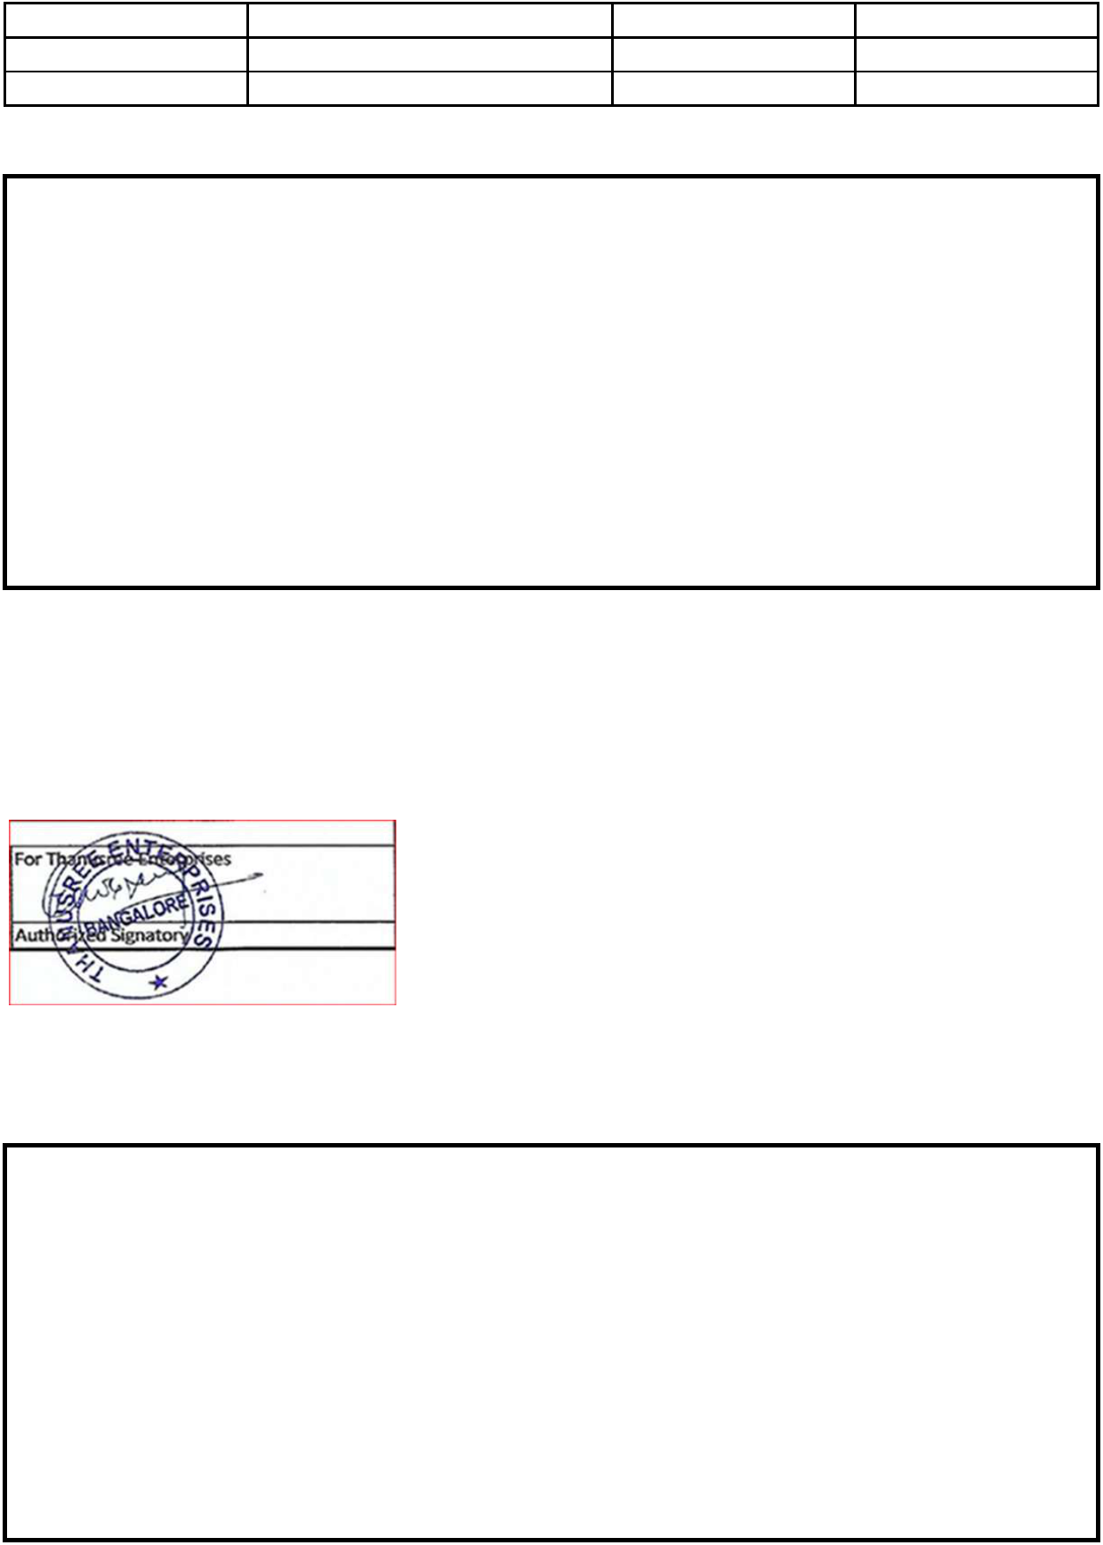

Reference Salary

Retirals

- Provident Fund (PF)

- Gratuity @ 4.8% Annual Remuneration

- Performance Linked Variable Pay*

- Annual Potential Compensation = (Annual Remuneration + Performance Linked Variable Pay)

OTHER BENEFITS:

By default, you will be enrolled in the Group Mediclaim Policy. You need to enroll your immediate family (Spouse & upto Four Children) within 45 days of joining. If you wish to do so, a nominal premium for covering you and your family will be charged to you unless you choose to opt out for yourself and family. Group Term Life and Accident Rider Coverage

Sincierly,

For Thanusree Enterprises

Vinod Kumar

Recruitment Lead

ACCEPTANCE OF APPOINTMENT TERMS AND CONDITIONS:

I agree that I have read, understand, and accept employment with Thanusree Enterprises under the terms and conditions stated above.

(Please sign below to confirm that you agree with the terms and conditions stated in this offer.)

Signature :

Printed Name :

Date: Date of Joining (if requesting an alternative date):

Address : No.157/3 1st Main Shammana Gowda Lyt Saraswathi Puram Ulsoor Bangalore -560008

